Semester One

Insert School Logo
Examination, 2024
Question/Answer Booklet

HUMAN BIOLOGY
UNIT 3

Name: __________________________________________________________

Teacher: ______________________________________________________

Time allowed for this paper

Reading time before commencing work: ten minutes
Working time for the paper: three hours

Materials required/recommended for this paper
To be provided by the supervisor
This Question/Answer Booklet
Multiple-choice Answer Sheet

To be provided by the candidate
Standard items: pens (blue/black preferred), pencils (including coloured), sharpener, correction fluid/tape, eraser, ruler, highlighters

Special items: up to three calculators, which do not have the capacity to create or store programmes or text, are permitted in this ATAR course examination

Important note to candidates
No other items may be taken into the examination room. It is your responsibility to ensure that you do not have any unauthorised material. If you have any unauthorised material with you, hand it to the supervisor before reading any further.
Structure of this paper

Section | Number of questions available | Number of questions to be answered | Suggested working time (minutes) | Marks available | Percentage of examination
Section One Multiple-choice | 30 | 30 | 40 | 30 | 30
Section Two Short answer | 7 | 7 | 90 | 106 | 50
Section Three Extended answer  Part A | 2 | 1 | 50 | 20 | 10
Part B | 2 | 1 | 50 | 20 | 10
 |  |  |  | Total | 100
Instructions to candidates

1. The rules for the conduct of the Western Australian examinations are detailed in the Year 12 Information Handbook 2023: Part II Examinations. Sitting this examination implies that you agree to abide by these rules.

2. Write your answers in this Question/Answer booklet preferably using a blue/black pen. Do not use erasable or gel pens.

3. Answer the questions according to the following instructions.

Section One: Answer all questions on the separate Multiple-choice answer sheet provided. For each question, shade the box to indicate your answer. Use only a blue or black pen to shade the boxes. Do not use erasable or gel pens. If you make a mistake, place a cross through that square, then shade your new answer. Do not erase or use correction fluid/tape. Marks will not be deducted for incorrect answers. No marks will be given if more than one answer is completed for any question.

Section Two: Write your answers in this Question/Answer booklet. Wherever possible, confine your answers to the line spaces provided.

Section Three: Consists of two parts each with two questions. You must answer one question from each part. Tick the box next to the question you are answering. Write your answers in this Question/Answer booklet

4. You must be careful to confine your answers to the specific questions asked and to follow any instructions that are specific to a particular question.

5. Supplementary pages for planning/continuing your answers to questions are provided at the end of this Question/Answer booklet. If you use these pages to continue an answer, indicate at the original answer where the answer is continued, i.e. give the page number.

Section One: Multiple–choice 30% (30 Marks)

This section has 30 questions. Answer all questions on the separate Multiple-choice answer sheet provided. For each question, shade the box to indicate your answer. Use only a blue or black pen to shade the boxes. Do not use erasable of gel pens. If you make a mistake, place a cross through that square, then shade your new answer. Do not erase or use correction fluid/tape. Marks will not be deducted for incorrect answers. No marks will be given if more than one answer is completed for any question.

Suggested working time: 40 minutes.

1. Which of the following would be stimulated by a decrease in external temperature?

(a) central thermoreceptors
(b) central chemoreceptors
(c) peripheral thermoreceptors
(d) peripheral chemoreceptors

2. Which of the following would not be considered a structural feature of a bacterial cell?

(a) slime layer
(b) protein coat
(c) cell membrane
(d) capsule

3. Cerumen is secreted by glands found in the

(a) ear.
(b) eye.
(c) skin.
(d) trachea.

4. Ameya has been having trouble sleeping at night. After a series of tests, she was prescribed a treatment of a synthetic hormone to help regulate her sleeping patterns.

Which of the following glands would most likely be affected in Ameya’s endocrine system?

(a) anterior pituitary
(b) posterior pituitary
(c) ovaries
(d) pineal gland

Two participants, after fasting overnight, had their blood glucose levels monitored for 5 hours after eating breakfast. The graph below shows the changes in each participant’s blood glucose levels from the point of consuming the meal (at 0 hours).

5. Which of the following would have the greatest impact on the validity of this experiment?

(a) the small number of participants
(b) the type of meal that each participant consumed
(c) the number of hours the blood glucose levels were monitored
(d) the fact that this experiment was only completed once

6. Which of the following would have been stimulated to cause the changes in blood glucose of Participant A seen between the hours of 1.5 – 3?

(a) beta cells of the islets of Langerhans
(b) thymus gland
(c) adrenal cortex
(d) alpha cells of the islets of Langerhans

7. Which of the following statements could best explain the blood glucose levels shown in the graph for Participant B?

(a) Participant B’s alpha cells are unable to respond to changes in blood glucose levels.
(b) Participant B’s beta cells are unable to respond to changes in blood glucose levels.
(c) Participant B most likely suffers from type diabetes insipidus.
(d) Participant B’s alpha cells cannot produce glycogen.

Questions 8 – 10 relate to the diagram below showing a simplified view of the process of gene therapy.
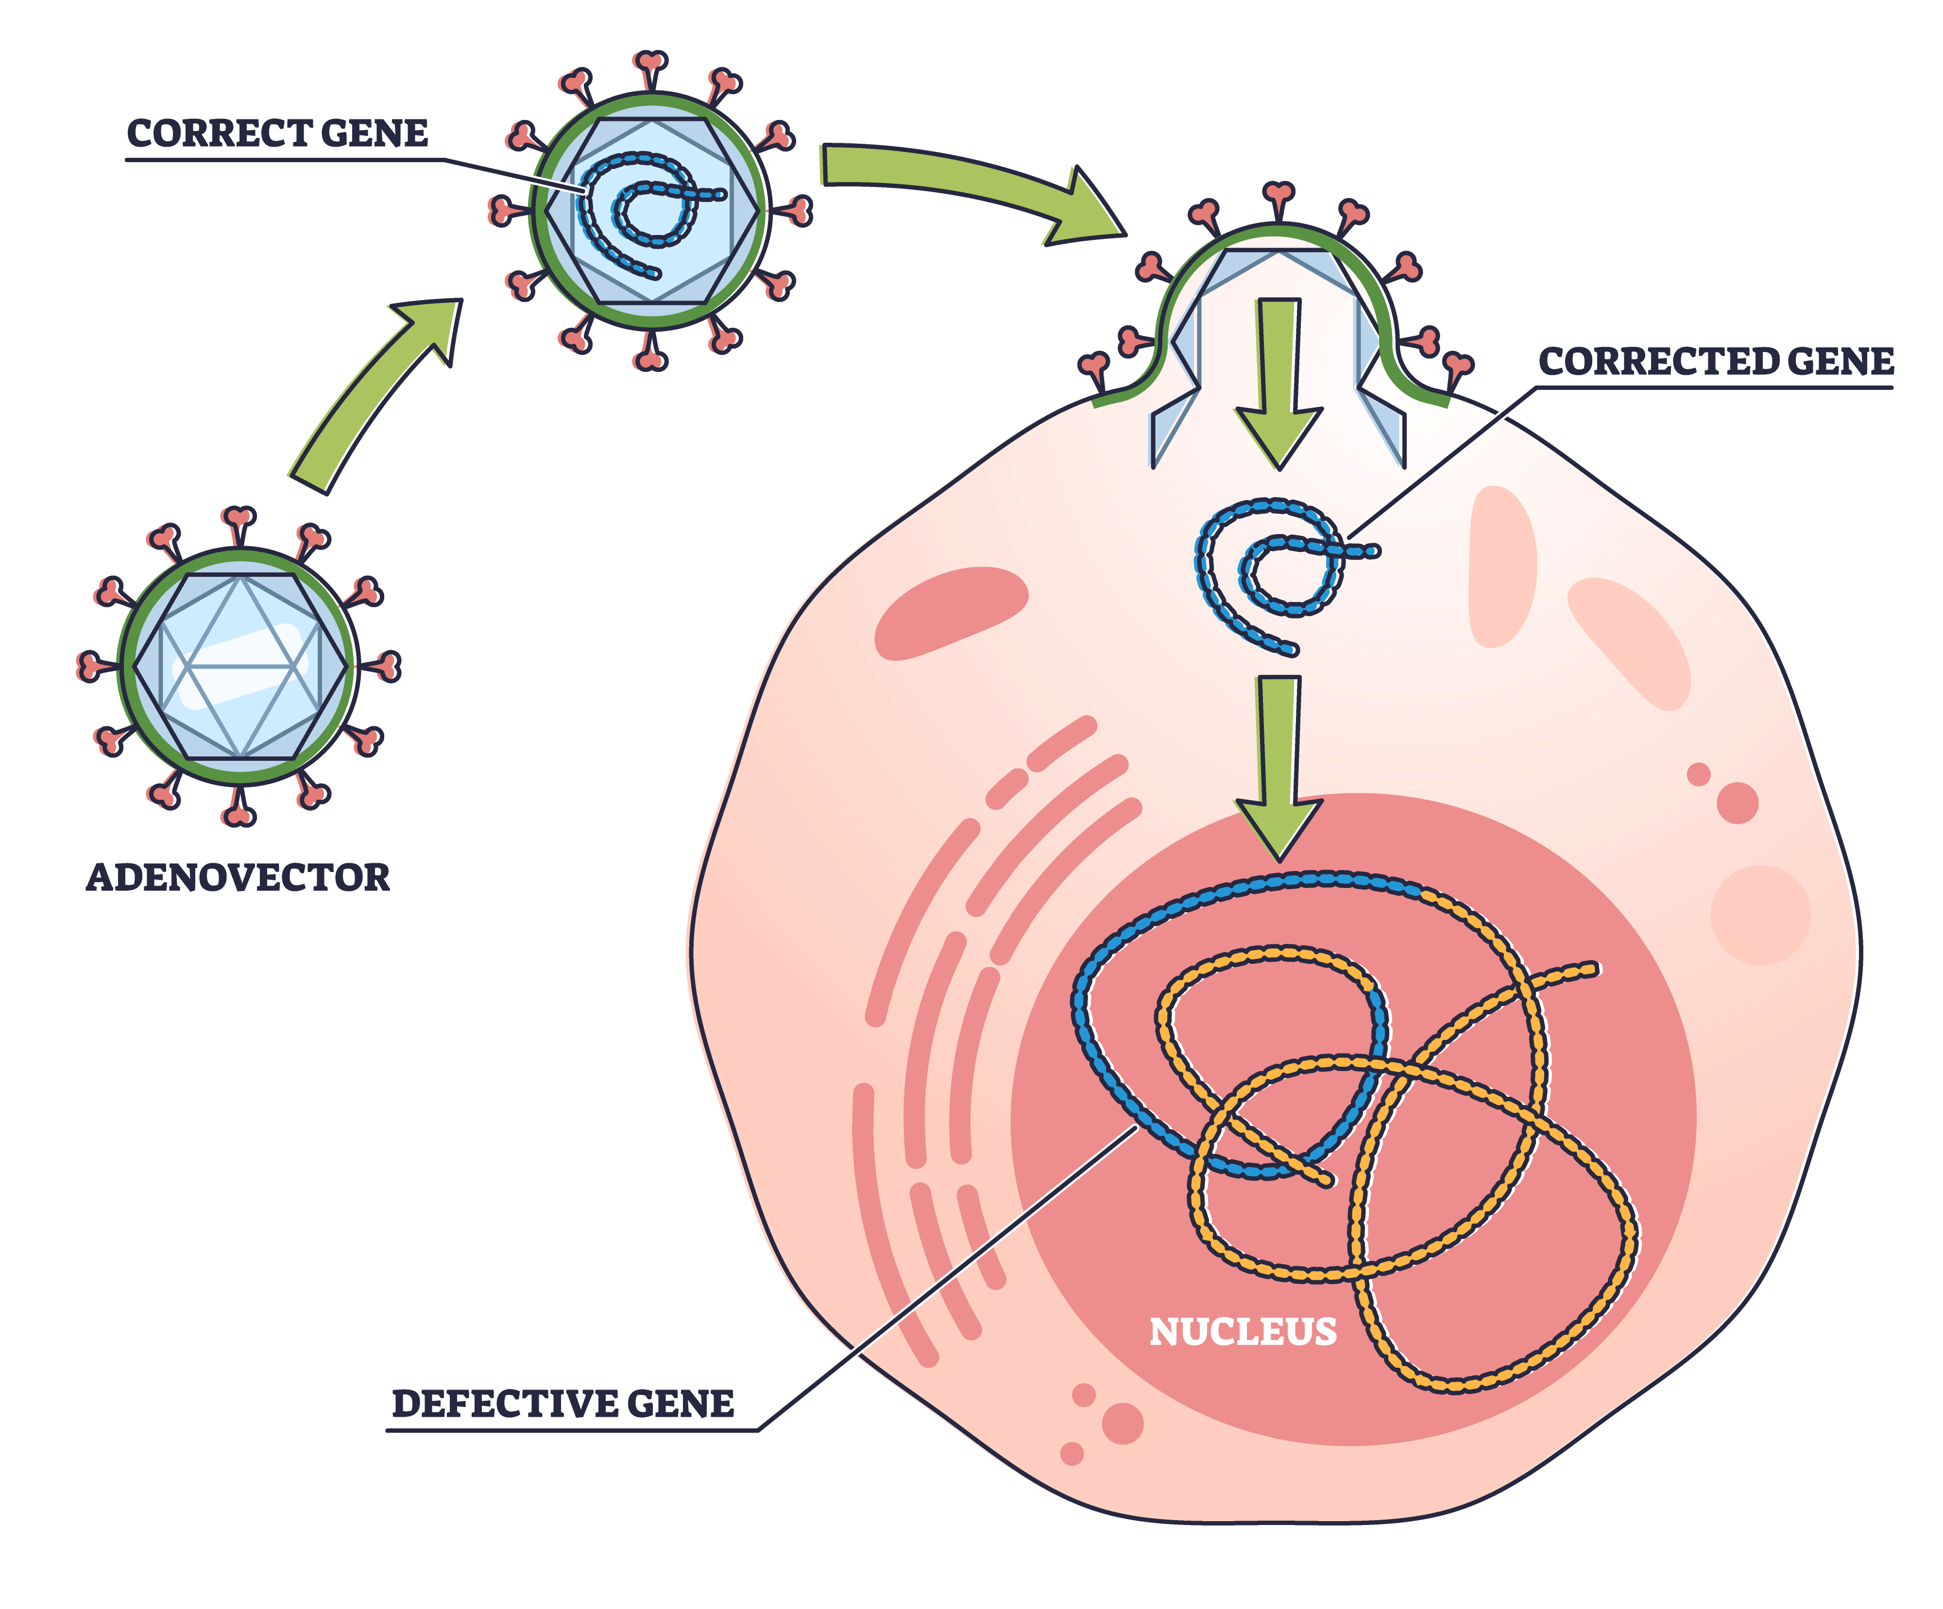

8. The ‘correct gene’ labelled in the diagram would have to be isolated from human DNA by

(a) DNA ligase
(b) taq polymerase
(c) a restriction enzyme
(d) DNA helicase

9. Which of the following diseases would be best suited for treatment through gene therapy?

(a) Parkinson’s disease
(b) Alzheimer’s disease
(c) tuberculosis
(d) cystic fibrosis

10. Adenoviruses are used as vectors in gene therapy because they can

(a) survive in temperatures needed for denaturation of DNA.
(b) integrate their DNA into the DNA of the host cell.
(c) bind to a receptor and alter the rate of transcription.
(d) activate a secondary messenger to inhibit the action of enzymes.

Questions 11 – 13 are related to the diagram of the pituitary gland shown below.

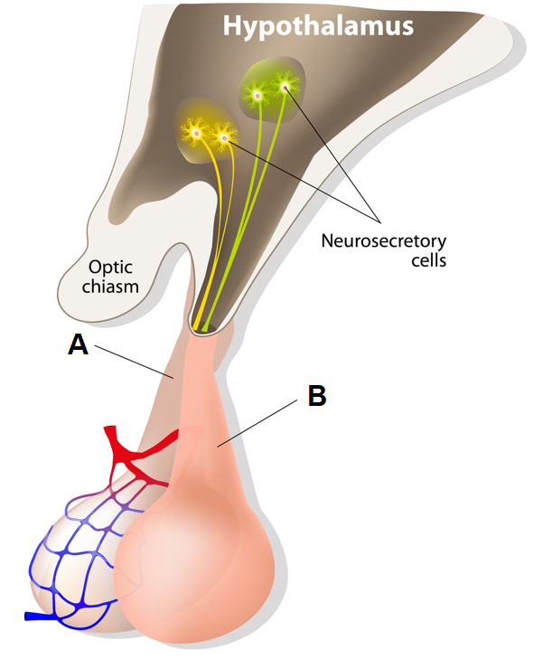

11. Which of the following hormones is released from the lobe labelled B in the diagram?

(a) aldosterone
(b) adrenocorticotropic hormone
(c) progesterone
(d) oxytocin

12. Which of the following hormones is produced in the lobe labelled B in the diagram?

(a) aldosterone
(b) antidiuretic hormone
(c) oxytocin
(d) none of the above

13. Gonadotropins, produced in the pituitary gland, target the gonads in males and females. Which of the following hormones will the ovaries produce in response to an increase in gonadotropins from the pituitary gland?

(a) oestrogen
(b) androgens
(c) follicle stimulating hormone
(d) luteinising hormone

Question 14 – 16 refer to the data in the table below.

The change in temperature of four different individuals after infection by a pathogen, over 4 hours.

 | Temperature (°C)
Time (hours) | Individual 1 | Individual 2 | Individual 3 | Individual 4
1 | 36.7 | 36.5 | 36.7 | 37
2 | 36.8 | 37 | 36.5 | 37.5
3 | 37.5 | 37.5 | 36.7 | 37.9
4 | 36.9 | 38 | 36.8 | 37.5

14. Which individual is most likely to have some form of immunity from the pathogen?

(a) individual 1
(b) individual 2
(c) individual 3
(d) individual 4

15. Which individual has the highest mean temperature over the 4 hours?

(a) individual 1
(b) individual 2
(c) individual 3
(d) individual 4

16. All individuals, except for one, are suffering from a mild fever. Which of the following best describes how a fever is stimulated?

(a) Pyrogens are released by the hypothalamus and cause the body to shiver and sweat leading to an increase in internal body temperature.
(b) Pyrogens are released by leucocytes, and target the hypothalamus, causing a response of shivering to increase heat production.
(c) Pyrogens are released by leucocytes and target the medulla oblongata, causing the response of shivering to increase heat production.
(d) Pyrogens are released by the hypothalamus, causing the response of shivering and vasoconstriction to increase internal body temperature.

17. Which of the following effectors would not be stimulated in response to a decrease in the external temperature?

(a) skeletal muscles
(b) skin arterioles
(c) adrenal medulla
(d) adrenal cortex

18. Which of the following diseases can cause hyperthyroidism?

(a) Graves’ disease
(b) Hashimoto’s disease
(c) Guillain-Barré syndrome
(d) Addison’s disease

19. The target for antidiuretic hormone is the

(a) proximal convoluted tubule and collecting duct.
(b) loop of Henle and distal convoluted tubule.
(c) distal convoluted tubule and proximal convoluted tubule.
(d) distal convoluted tubule and collecting duct.

20. Homer was building a kennel for his dog when he stepped on a rusty nail. He then exclaimed he would require a tetanus shot, which is a blood serum containing antibodies. What type of immunity would Homer get from the tetanus shot?

(a) passive, artificial immunity
(b) active, artificial immunity
(c) passive, natural immunity
(d) active, natural immunity

21. Which of the following organs is not directly involved with the regulation of water and salts in body fluids?

(a) the large intestine
(b) the kidneys
(c) the skin
(d) the pancreas

22. Which of the following is not a response that can occur due to stimulation of the parasympathetic nervous system?

(a) constriction of bronchioles
(b) constriction of the muscles of the urinary bladder
(c) decreased secretion of saliva
(d) increased uptake of glucose by the liver

23. A bundle of nerve fibres in the peripheral nervous system is known as a/an

(a) tract.
(b) nerve.
(c) axon.
(d) dendrite.

Questions 24 – 26 refer to the image below showing the voltage changes before, during and after an action potential.

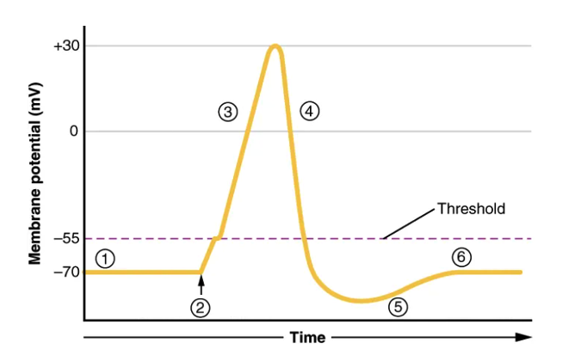

24. The part labelled 3 is referred to as

(a) depolarisation
(b) repolarisation
(c) hyperpolarisation
(d) polarisation

25. During the period of time labelled 5, which of the following would best describe what is occurring at the membrane?

(a) The voltage-gated sodium channels are open, pumping out sodium ions to bring membrane back to resting membrane potential.
(b) The voltage-gated sodium and potassium channels are both closed, and the sodium-potassium pump is working to bring the membrane back towards resting state.
(c) The voltage-gated potassium channels are open, causing an influx of potassium ions to bring membrane back to rest.
(d) The sodium-potassium pump is switched off, to allow voltage-gated sodium and potassium channels the chance to bring the membrane back to rest.

26. At the threshold, which of the following channels would be stimulated?

(a) voltage-gated potassium channels
(b) voltage-gated sodium channels
(c) ligand-gated sodium channels
(d) mechanically-gated sodium channels

27. Damage to the medulla oblongata could lead to

(a) jerky movements.
(b) trouble sleeping.
(c) blood pressure problems.
(d) an increase in internal body temperature.

28. Which of the following is not a method of heat transfer that can increase heat loss?

(a) increased conduction of heat from the body
(b) increased convection of heat from the body
(c) increased metabolism in cells
(d) increased evaporation of sweat

29. An increase in solute concentration in the blood causes a/an

(a) increase in osmotic pressure.
(b) decrease in osmotic pressure.
(c) decrease in osmotic concentration.
(d) increase in insulin production.

30. The human immunodeficiency virus (HIV) is able to be spread by

(a) direct contact.
(b) airborne transmission.
(c) infection by droplets.
(d) transfer of body fluids.

End of Section One
Section Two: Short answer 50% (106 Marks)

This section has seven questions. Answer all questions. Write your answers in the spaces provided.

Supplementary pages for planning/continuing your answers to questions are provided at the end of this Question/Answer booklet. If you use these pages to continue an answer, indicate at the original answer where the answer is continued, i.e. give the page number.

Suggested working time: 90 minutes.

Question 31 (14 marks)

Chronic obstructive pulmonary disease (COPD) is a general term that refers to a number of different lung diseases that affect airflow and gas exchange. Symptoms of COPD can often be made worse by infection from pathogens.

(a) Describe and explain how features of the respiratory system help to prevent the entry of pathogens. (4 marks)

______________________________________________________________________

______________________________________________________________________

______________________________________________________________________

______________________________________________________________________

______________________________________________________________________

______________________________________________________________________

______________________________________________________________________

______________________________________________________________________

______________________________________________________________________

COPD, when made worse by infection, may lead to hypercapnia – an increase in the carbon dioxide levels above normal. This can cause pH changes that may be detected by the receptors identified by the letters A and B on the diagram on the following page.

(b) Explain why hypercapnia could lead to changes in pH. (3 marks)

______________________________________________________________________

______________________________________________________________________

______________________________________________________________________

______________________________________________________________________
Question 31 (continued)
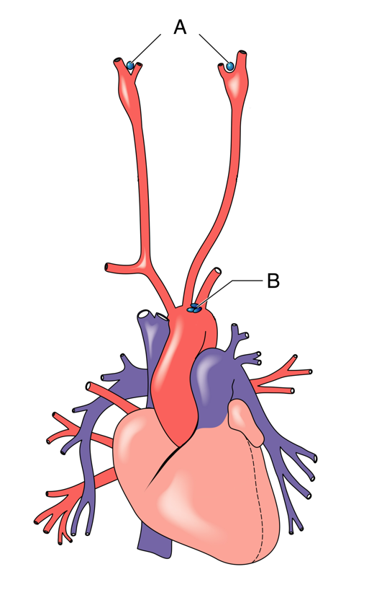

(c) Name the receptors labelled A and B in the diagram. (2 marks)

A ________________________________________________________________

B ________________________________________________________________

(d) Describe the normal homeostatic response to the changes in pH caused by hypercapnia. (5 marks)

______________________________________________________________________

______________________________________________________________________

______________________________________________________________________

______________________________________________________________________

______________________________________________________________________

______________________________________________________________________

______________________________________________________________________

______________________________________________________________________

______________________________________________________________________

______________________________________________________________________

______________________________________________________________________
Question 32 (19 marks)

The DTPa vaccine is part of the Australian vaccination schedule that protects against three different bacterial infections. It is comprised of toxoids for diphtheria and tetanus, as well as an inactivated pertussis.

(a) Contrast toxoid and inactivated vaccines. (2 marks)

______________________________________________________________________

______________________________________________________________________

______________________________________________________________________

______________________________________________________________________

(b) This type of vaccine can be given early in infancy (at around 2 months), whereas the live attenuated MMR vaccine is not given until a baby is 12 months old. Explain why this may be the case. (3 marks)

______________________________________________________________________

______________________________________________________________________

______________________________________________________________________

______________________________________________________________________

______________________________________________________________________

______________________________________________________________________

______________________________________________________________________

______________________________________________________________________

Question 32 (continued)

The incomplete figure below represents DTPa antibody production over time. The point labelled
A on the figure shows when Mariah, at 4 months old, received the DTPa vaccine.
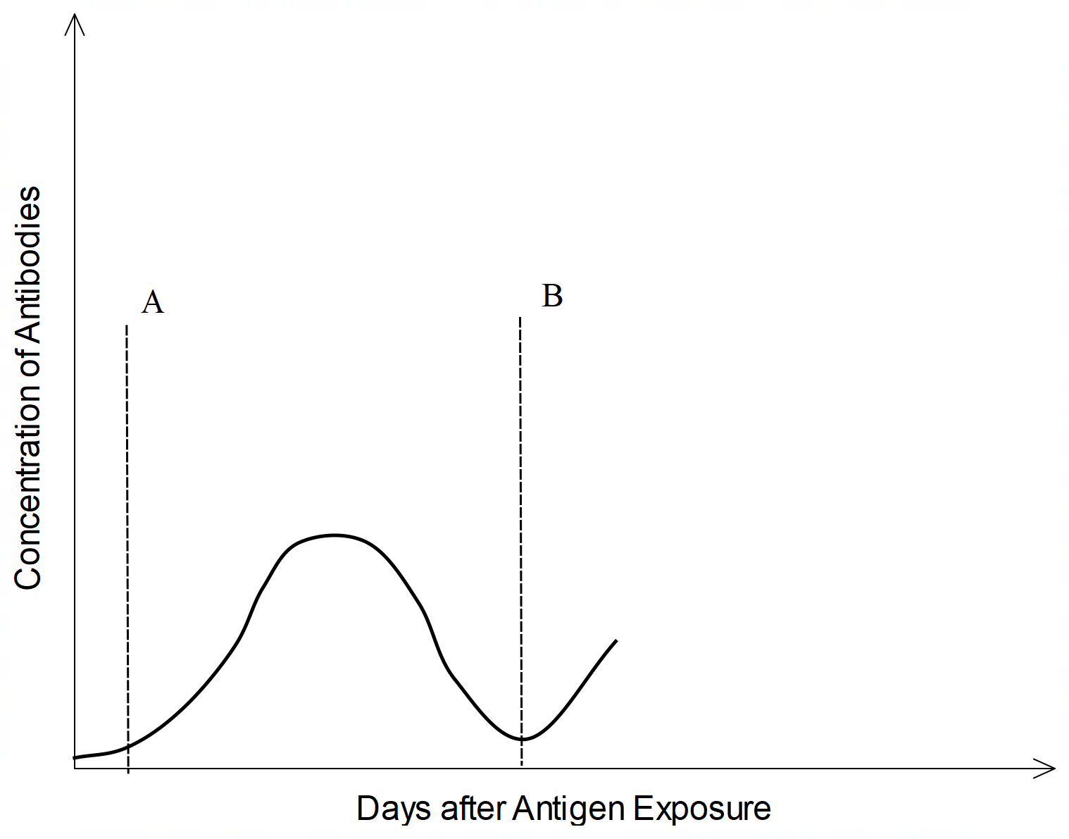

(c) Describe what would be occurring in Mariah’s immune system after point A. (6 marks)

______________________________________________________________________

______________________________________________________________________

______________________________________________________________________

______________________________________________________________________

______________________________________________________________________

______________________________________________________________________

______________________________________________________________________

______________________________________________________________________

______________________________________________________________________

______________________________________________________________________

______________________________________________________________________

As a teenager, Mariah and her friend Renae were both exposed to the pertussis bacterium during an outbreak at their school, indicated by the label B on the figure. Renae was not vaccinated as a child.

(d) Complete the figure shown above by sketching and labelling the remaining curves to represent the antibody production for Mariah and Renae after exposure to the live pertussis bacterium. (2 marks)
(e) Explain the difference in the two curves sketched in part (d). (4 marks)

______________________________________________________________________

______________________________________________________________________

______________________________________________________________________

______________________________________________________________________

______________________________________________________________________

______________________________________________________________________

______________________________________________________________________

______________________________________________________________________

______________________________________________________________________

______________________________________________________________________

(f) Suggest two reasons why Renae’s parents may have chosen not to have her vaccinated when she was an infant. (2 marks)

______________________________________________________________________

______________________________________________________________________

______________________________________________________________________

______________________________________________________________________

______________________________________________________________________

______________________________________________________________________

______________________________________________________________________

Question 33 (19 marks)

Osteoporosis, a bone condition characterised by brittle bones and reduced bone density, has been linked to a deficiency in the hormone calcitonin. An experiment was recently carried out to test the effect of a synthetic version of calcitonin as a treatment for sufferers of osteoporosis.

For the experiment 20 people suffering from osteoporosis were split into an experimental and a control group. The relevant group received either a daily dose of synthetic calcitonin, or a placebo.

Over the course of 6 weeks, the blood calcium levels of each group were measured and recorded at the end of each week. The average levels for each group over the course of the experiment are shown in the table below.

 | Average blood calcium levels (mg/dL)
Week | Group One | Group Two
1 | 12.5 | 12.5
2 | 11.0 | 12.1
3 | 10.4 | 11.9
4 | 9.3 | 12.3
5 | 9.0 | 13.0
6 | 8.9 | 11.0

(a) Which group was the control group? Justify your answer by referring to the data provided. (2 marks)

______________________________________________________________________

______________________________________________________________________

______________________________________________________________________

______________________________________________________________________

______________________________________________________________________

(b) Identify the independent and dependent variable for this experiment. (2 marks)

Independent __________________________________________________________

Dependent __________________________________________________________

(c) Suggest one controlled variable for this experiment. (1 mark)

______________________________________________________________________

______________________________________________________________________
(d) Determine the percentage change, over the 6 weeks, in the calcium levels for the group that received the treatment. Show working. (3 marks)

______________________________________________________________________

______________________________________________________________________

______________________________________________________________________

______________________________________________________________________

______________________________________________________________________

(e) Graph the data on the grid below. (5 marks)

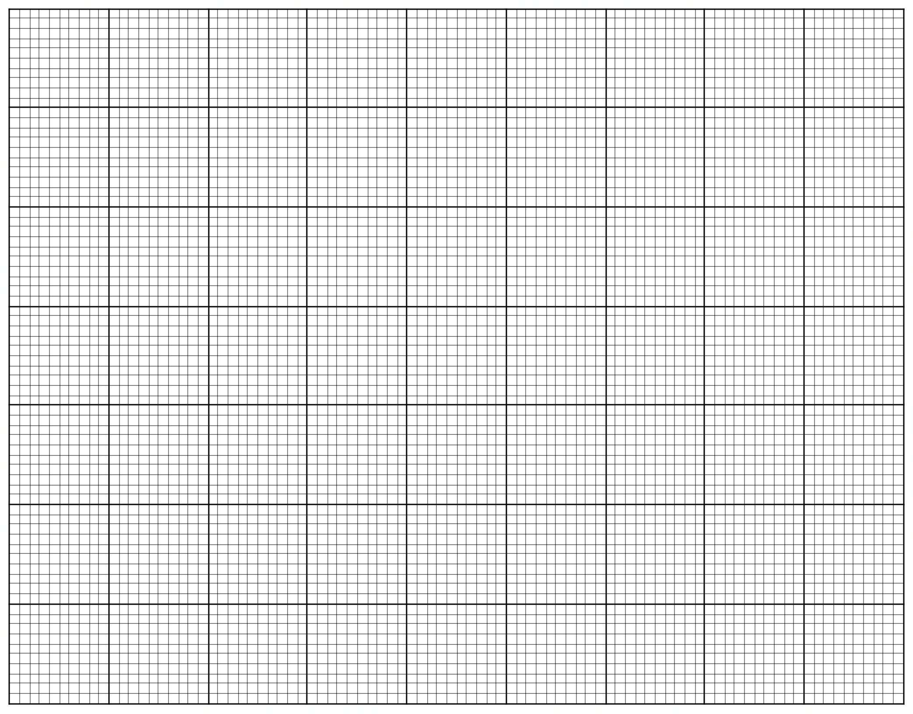

A spare grid is provided at the end of this Question/Answer Booklet. If you need to use it, cross
out this attempt and indicate that you have redrawn it on the spare grid.

Question 33 (continued)

(e) Explain the changes in the blood calcium levels for the group that received the treatment. (2 marks)

______________________________________________________________________

______________________________________________________________________

______________________________________________________________________

______________________________________________________________________

______________________________________________________________________

The diagram below shows the back view of the thyroid gland.

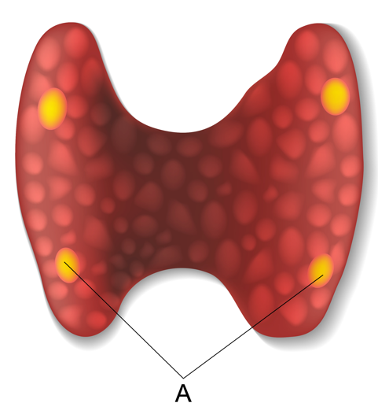

(f) Explain how a hypersecretion of the hormone from gland A could also lead to osteoporosis. (4 marks)

______________________________________________________________________

______________________________________________________________________

______________________________________________________________________

______________________________________________________________________

______________________________________________________________________

______________________________________________________________________

______________________________________________________________________

______________________________________________________________________

______________________________________________________________________
Question 34 (16 marks)

The diagram below shows the structures of the central nervous system.

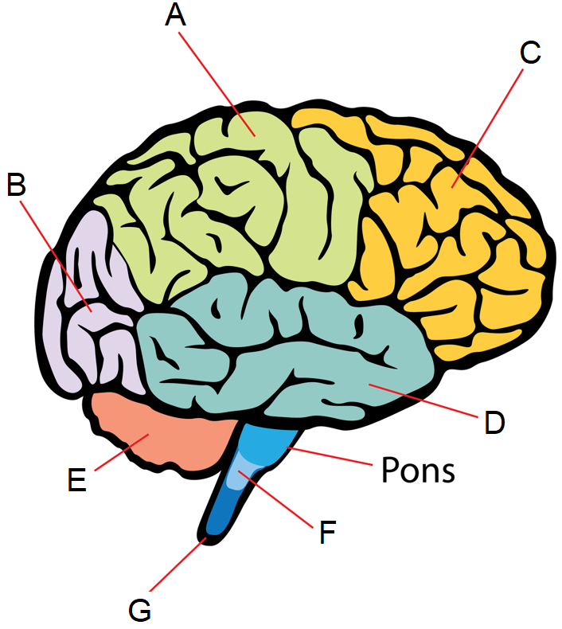

(a) Complete the table below, by identifying the parts labelled in the diagram. (3 marks)

Label | Name of structure
A
C
F

(b) Describe the function of the area labelled E. (2 marks)

______________________________________________________________________

______________________________________________________________________

______________________________________________________________________

Question 34 (continued)

(c) Gemma suffered a blow to the back of the head, affecting the area labelled B. Name this part of the cerebrum and suggest and explain the effect damage to this area may have on Gemma. (3 marks)

______________________________________________________________________

______________________________________________________________________

______________________________________________________________________

______________________________________________________________________

______________________________________________________________________

______________________________________________________________________

______________________________________________________________________

______________________________________________________________________

Progressive, neurodegenerative diseases, such as Alzheimer’s and Parkinson’s, can cause changes to the structure and function of the cerebrum. One of the major concerns linked to Alzheimer’s is the breakdown of communications between neurons.

(d) Describe what is meant by a progressive, neurodegenerative disease. (2 marks)

______________________________________________________________________

______________________________________________________________________

______________________________________________________________________

______________________________________________________________________

(e) Describe how an action potential is transmitted across a synapse and explain the effect of this breakdown of communication on Alzheimer’s patients. (6 marks)

______________________________________________________________________

______________________________________________________________________

______________________________________________________________________

______________________________________________________________________

______________________________________________________________________

______________________________________________________________________

______________________________________________________________________

______________________________________________________________________

______________________________________________________________________

______________________________________________________________________

______________________________________________________________________

______________________________________________________________________

______________________________________________________________________

______________________________________________________________________

______________________________________________________________________

Question 35 (14 marks)

The diagram below shows the cross section of an adrenal gland.

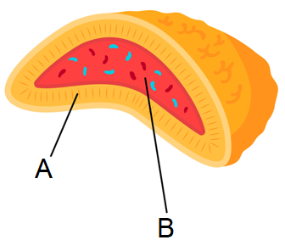

(a) State the hormone(s) secreted by each part labelled in the diagram. (2 marks)

Label | Hormone(s) secreted
A
B

(b) When the body is working under stressful conditions the adrenal gland could be stimulated. Name the subdivision of the peripheral nervous system this is linked to and describe two physiological effects of the stimulation of this subdivision. (3 marks)

______________________________________________________________________

______________________________________________________________________

______________________________________________________________________

______________________________________________________________________

______________________________________________________________________

______________________________________________________________________

______________________________________________________________________

______________________________________________________________________

The adrenal glands are also linked to blood glucose regulation and metabolism.

(c) Describe the role of part A in blood glucose regulation. (4 marks)

______________________________________________________________________

______________________________________________________________________

______________________________________________________________________

______________________________________________________________________

______________________________________________________________________

______________________________________________________________________

______________________________________________________________________

______________________________________________________________________

______________________________________________________________________

______________________________________________________________________

(d) Describe the role of the adrenal gland in regulating metabolism and explain how an increase in metabolism could lead to a need to regulate blood glucose levels. (5 marks)

______________________________________________________________________

______________________________________________________________________

______________________________________________________________________

______________________________________________________________________

______________________________________________________________________

______________________________________________________________________

______________________________________________________________________

______________________________________________________________________

______________________________________________________________________

______________________________________________________________________

______________________________________________________________________

Question 36 (11 marks)

The following diagram shows the different types of neurons found in the human body.

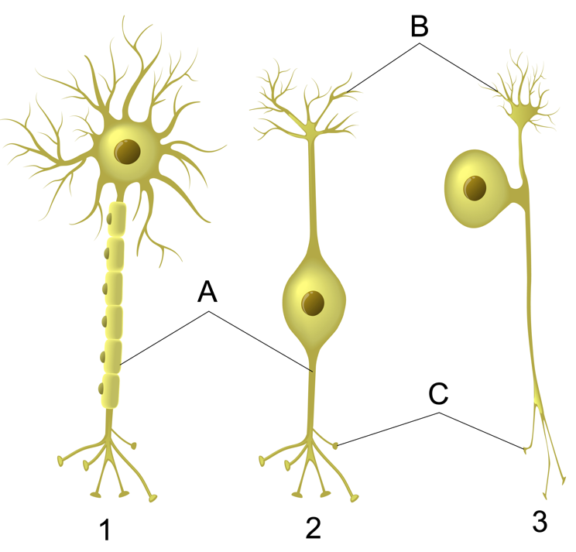

(a) Outline the function of the parts labelled A and B. (2 marks)

A ________________________________________________________________

______________________________________________________________________

B ________________________________________________________________

______________________________________________________________________

(b) Identify which neuron(s), using the numbers provided, would be found in the efferent and afferent nervous systems respectively. Justify your answer. (4 marks)

Afferent: _______________________________________________________________

______________________________________________________________________

______________________________________________________________________

______________________________________________________________________

Efferent: _______________________________________________________________

______________________________________________________________________

______________________________________________________________________

______________________________________________________________________

______________________________________________________________________
(c) The neuron labelled with the number 1 shows the myelin sheath. Explain the difference in propagation of an action potential in a myelinated compared to an unmyelinated fibre. (5 marks)

______________________________________________________________________

______________________________________________________________________

______________________________________________________________________

______________________________________________________________________

______________________________________________________________________

______________________________________________________________________

______________________________________________________________________

______________________________________________________________________

______________________________________________________________________

______________________________________________________________________

______________________________________________________________________

Question 37 (13 marks)

Homeostatic processes involve nerves and hormones in maintaining the body’s internal environment within tolerance limits, through physiological and behavioural responses.

(a) Define what is meant by tolerance limits, using an example to aid your answer. (2 marks)

______________________________________________________________________

______________________________________________________________________

______________________________________________________________________

______________________________________________________________________

(b) Distinguish between physiological and behavioural responses. (2 marks)

______________________________________________________________________

______________________________________________________________________

______________________________________________________________________

______________________________________________________________________

______________________________________________________________________

______________________________________________________________________

Both hormonal and nervous responses rely on receptors to maintain homeostasis.

(c) Describe the role of receptors in the mode of action of hormones. (3 marks)

______________________________________________________________________

______________________________________________________________________

______________________________________________________________________

______________________________________________________________________

______________________________________________________________________

______________________________________________________________________

______________________________________________________________________

______________________________________________________________________

______________________________________________________________________
(d) Identify three different types of nervous system receptors found in the skin and describe their role. (6 marks)

One: ________________________________________________________________

______________________________________________________________________

______________________________________________________________________

______________________________________________________________________

Two: ________________________________________________________________

______________________________________________________________________

______________________________________________________________________

______________________________________________________________________

Three: ________________________________________________________________

______________________________________________________________________

______________________________________________________________________

______________________________________________________________________

End of Section Two
Section Three: Extended answer 20% (40 Marks)

This section has four questions. You must answer two questions.

Questions 38 and 39 are from Part A. Questions 40 and 41 are from Part B. Answer one question from Part A and one question from Part B.

Responses could include clearly labelled diagrams with explanatory notes; list of points with linking sentences; clearly labelled tables and graphs; and annotated flow diagrams with introductory notes.

Supplementary pages for planning/continuing your answers to questions are provided at the end of this Question/Answer booklet. If you use these pages to continue an answer, indicate at the original answer where the answer is continued, i.e. give the page number.

Suggested working time: 50 minutes.

Part A

Choose either Question 38 or Question 39.

Indicate the question you will answer by ticking the box next to the question. Write your answer on pages 30 – 34. When you have answered your first question, turn to page 35 and indicate on that page the second question you will answer.

Question 38 (20 marks)

The central nervous system is critical to normal, human body function. The hypothalamus, a specific area of the brain, co-ordinates the regulation of internal body temperature, errors of which may impact metabolic rate and lead to an intolerance to heat.

(a) The brain co-ordinates many essential body functions, and therefore needs to be protected. Describe how the brain is protected. (6 marks)

(b) Describe and explain two physiological mechanisms initiated by the hypothalamus that normally work to maintain internal temperature when it is at risk of rising to levels above the upper tolerance limit. (6 marks)

(c) Explain why a dysfunctional hypothalamus could cause a disorder of the endocrine system that results in an intolerance to heat. (8 marks)

Question 39 (20 marks)

Mycobacterium tuberculosis is a type of pathogenic bacteria that initially enters and infects the respiratory system but can sometimes affect the function of certain endocrine glands. Infection of the adrenal glands may lead to a condition known as Addison’s disease, where insufficient hormones are produced from the adrenal cortex, leading to symptoms such as low blood pressure (hypotension).

(a) Describe the mode of transmission for the M. tuberculosis bacterium and explain how antibiotics could possibly treat this infection. (6 marks)

(b) Name and describe the function of the two hormones released by the adrenal cortex and explain how Addison’s disease could lead to low blood volume, due to low water retention, therefore causing hypotension. (7 marks)

(c) Another possible cause of Addison’s disease could be a dysfunction of the hypothalamus. Explain how a dysfunction of the hypothalamus could cause this disease. (7 marks)

Question number: _______________

____________________________________________________________________________

____________________________________________________________________________

____________________________________________________________________________

____________________________________________________________________________

____________________________________________________________________________

____________________________________________________________________________

____________________________________________________________________________

____________________________________________________________________________

____________________________________________________________________________

____________________________________________________________________________

____________________________________________________________________________

____________________________________________________________________________

____________________________________________________________________________

____________________________________________________________________________

____________________________________________________________________________

____________________________________________________________________________

____________________________________________________________________________

____________________________________________________________________________

____________________________________________________________________________

____________________________________________________________________________

____________________________________________________________________________

____________________________________________________________________________

____________________________________________________________________________

____________________________________________________________________________

____________________________________________________________________________

____________________________________________________________________________
Question number: _______________

____________________________________________________________________________

____________________________________________________________________________

____________________________________________________________________________

____________________________________________________________________________

____________________________________________________________________________

____________________________________________________________________________

____________________________________________________________________________

____________________________________________________________________________

____________________________________________________________________________

____________________________________________________________________________

____________________________________________________________________________

____________________________________________________________________________

____________________________________________________________________________

____________________________________________________________________________

____________________________________________________________________________

____________________________________________________________________________

____________________________________________________________________________

____________________________________________________________________________

____________________________________________________________________________

____________________________________________________________________________

____________________________________________________________________________

____________________________________________________________________________

____________________________________________________________________________

____________________________________________________________________________

____________________________________________________________________________

____________________________________________________________________________
Question number: _______________

____________________________________________________________________________

____________________________________________________________________________

____________________________________________________________________________

____________________________________________________________________________

____________________________________________________________________________

____________________________________________________________________________

____________________________________________________________________________

____________________________________________________________________________

____________________________________________________________________________

____________________________________________________________________________

____________________________________________________________________________

____________________________________________________________________________

____________________________________________________________________________

____________________________________________________________________________

____________________________________________________________________________

____________________________________________________________________________

____________________________________________________________________________

____________________________________________________________________________

____________________________________________________________________________

____________________________________________________________________________

____________________________________________________________________________

____________________________________________________________________________

____________________________________________________________________________

____________________________________________________________________________

____________________________________________________________________________

____________________________________________________________________________
Question number: _______________

____________________________________________________________________________

____________________________________________________________________________

____________________________________________________________________________

____________________________________________________________________________

____________________________________________________________________________

____________________________________________________________________________

____________________________________________________________________________

____________________________________________________________________________

____________________________________________________________________________

____________________________________________________________________________

____________________________________________________________________________

____________________________________________________________________________

____________________________________________________________________________

____________________________________________________________________________

____________________________________________________________________________

____________________________________________________________________________

____________________________________________________________________________

____________________________________________________________________________

____________________________________________________________________________

____________________________________________________________________________

____________________________________________________________________________

____________________________________________________________________________

____________________________________________________________________________

____________________________________________________________________________

____________________________________________________________________________

____________________________________________________________________________
Question number: _______________

____________________________________________________________________________

____________________________________________________________________________

____________________________________________________________________________

____________________________________________________________________________

____________________________________________________________________________

____________________________________________________________________________

____________________________________________________________________________

____________________________________________________________________________

____________________________________________________________________________

____________________________________________________________________________

____________________________________________________________________________

____________________________________________________________________________

____________________________________________________________________________

____________________________________________________________________________

____________________________________________________________________________

____________________________________________________________________________

____________________________________________________________________________

____________________________________________________________________________

____________________________________________________________________________

____________________________________________________________________________

____________________________________________________________________________

____________________________________________________________________________

____________________________________________________________________________

____________________________________________________________________________

____________________________________________________________________________

____________________________________________________________________________
Part B

Choose either Question 40 or Question 41.

Indicate the question you will answer by ticking the box next to the question. Write your answer on the pages provided.

Question 40 (20 marks)

In contrast to the somatic nervous system, the autonomic division is usually involved with involuntary responses. However, the spinal reflex arc is an exception to this as it is an involuntary process involving nerves of the somatic nervous system.

(a) Outline three other contrasting points between the autonomic and somatic nervous systems and describe the pathway of the spinal reflex arc, explaining why it is considered involuntary. (8 marks)

The condition known as ‘long COVID’ can cause a type of orthostatic intolerance where standing upright can lead to an increase in heart rate and low blood pressure, causing dizziness and fainting. This could possibly be linked to a viral infection of the autonomic nervous system.

(b) Describe the cell-mediated immune response after exposure to a virus such as the COVID-19 virus and explain how an infection of the autonomic nervous system could cause the condition and symptoms described. (12 marks)

Question 41 (20 marks)

Evangeline has been working hard in training for a triathlon, cycling in various weather conditions. On one particularly hot day she finds herself exhausted and drenched in sweat so she takes a break for an ice cream. Despite the comfort she receives from the ice cream, after eating it Evangeline finds she feels dizzy and trips, scraping her knee on the pavement.

(a) One of the key hormones released by Evangeline’s endocrine system to maintain her internal fluid balance is a small peptide hormone. Describe the mode of action for this hormone. (4 marks)

(b) Describe and explain how and why Evangeline’s endocrine system would be working to maintain her body fluid concentrations during her training. (9 marks)

(b) Describe and explain the appearance of the injury after Evangeline scrapes her knee. (7 marks)

End of questions
Question number: _______________

____________________________________________________________________________

____________________________________________________________________________

____________________________________________________________________________

____________________________________________________________________________

____________________________________________________________________________

____________________________________________________________________________

____________________________________________________________________________

____________________________________________________________________________

____________________________________________________________________________

____________________________________________________________________________

____________________________________________________________________________

____________________________________________________________________________

____________________________________________________________________________

____________________________________________________________________________

____________________________________________________________________________

____________________________________________________________________________

____________________________________________________________________________

____________________________________________________________________________

____________________________________________________________________________

____________________________________________________________________________

____________________________________________________________________________

____________________________________________________________________________

____________________________________________________________________________

____________________________________________________________________________

____________________________________________________________________________

____________________________________________________________________________
Question number: _______________

____________________________________________________________________________

____________________________________________________________________________

____________________________________________________________________________

____________________________________________________________________________

____________________________________________________________________________

____________________________________________________________________________

____________________________________________________________________________

____________________________________________________________________________

____________________________________________________________________________

____________________________________________________________________________

____________________________________________________________________________

____________________________________________________________________________

____________________________________________________________________________

____________________________________________________________________________

____________________________________________________________________________

____________________________________________________________________________

____________________________________________________________________________

____________________________________________________________________________

____________________________________________________________________________

____________________________________________________________________________

____________________________________________________________________________

____________________________________________________________________________

____________________________________________________________________________

____________________________________________________________________________

____________________________________________________________________________

____________________________________________________________________________
Question number: _______________

____________________________________________________________________________

____________________________________________________________________________

____________________________________________________________________________

____________________________________________________________________________

____________________________________________________________________________

____________________________________________________________________________

____________________________________________________________________________

____________________________________________________________________________

____________________________________________________________________________

____________________________________________________________________________

____________________________________________________________________________

____________________________________________________________________________

____________________________________________________________________________

____________________________________________________________________________

____________________________________________________________________________

____________________________________________________________________________

____________________________________________________________________________

____________________________________________________________________________

____________________________________________________________________________

____________________________________________________________________________

____________________________________________________________________________

____________________________________________________________________________

____________________________________________________________________________

____________________________________________________________________________

____________________________________________________________________________

____________________________________________________________________________
Question number: _______________

____________________________________________________________________________

____________________________________________________________________________

____________________________________________________________________________

____________________________________________________________________________

____________________________________________________________________________

____________________________________________________________________________

____________________________________________________________________________

____________________________________________________________________________

____________________________________________________________________________

____________________________________________________________________________

____________________________________________________________________________

____________________________________________________________________________

____________________________________________________________________________

____________________________________________________________________________

____________________________________________________________________________

____________________________________________________________________________

____________________________________________________________________________

____________________________________________________________________________

____________________________________________________________________________

____________________________________________________________________________

____________________________________________________________________________

____________________________________________________________________________

____________________________________________________________________________

____________________________________________________________________________

____________________________________________________________________________

____________________________________________________________________________
Question number: _______________

____________________________________________________________________________

____________________________________________________________________________

____________________________________________________________________________

____________________________________________________________________________

____________________________________________________________________________

____________________________________________________________________________

____________________________________________________________________________

____________________________________________________________________________

____________________________________________________________________________

____________________________________________________________________________

____________________________________________________________________________

____________________________________________________________________________

____________________________________________________________________________

____________________________________________________________________________

____________________________________________________________________________

____________________________________________________________________________

____________________________________________________________________________

____________________________________________________________________________

____________________________________________________________________________

____________________________________________________________________________

____________________________________________________________________________

____________________________________________________________________________

____________________________________________________________________________

____________________________________________________________________________

____________________________________________________________________________

____________________________________________________________________________
Supplementary page

Question number: _______________

____________________________________________________________________________

____________________________________________________________________________

____________________________________________________________________________

____________________________________________________________________________

____________________________________________________________________________

____________________________________________________________________________

____________________________________________________________________________

____________________________________________________________________________

____________________________________________________________________________

____________________________________________________________________________

____________________________________________________________________________

____________________________________________________________________________

____________________________________________________________________________

____________________________________________________________________________

____________________________________________________________________________

____________________________________________________________________________

____________________________________________________________________________

____________________________________________________________________________

____________________________________________________________________________

____________________________________________________________________________

____________________________________________________________________________

____________________________________________________________________________

____________________________________________________________________________

____________________________________________________________________________

____________________________________________________________________________
Supplementary page

Question number: _______________

____________________________________________________________________________

____________________________________________________________________________

____________________________________________________________________________

____________________________________________________________________________

____________________________________________________________________________

____________________________________________________________________________

____________________________________________________________________________

____________________________________________________________________________

____________________________________________________________________________

____________________________________________________________________________

____________________________________________________________________________

____________________________________________________________________________

____________________________________________________________________________

____________________________________________________________________________

____________________________________________________________________________

____________________________________________________________________________

____________________________________________________________________________

____________________________________________________________________________

____________________________________________________________________________

____________________________________________________________________________

____________________________________________________________________________

____________________________________________________________________________

____________________________________________________________________________

____________________________________________________________________________

____________________________________________________________________________
Supplementary page

Question number: _______________

____________________________________________________________________________

____________________________________________________________________________

____________________________________________________________________________

____________________________________________________________________________

____________________________________________________________________________

____________________________________________________________________________

____________________________________________________________________________

____________________________________________________________________________

____________________________________________________________________________

____________________________________________________________________________

____________________________________________________________________________

____________________________________________________________________________

____________________________________________________________________________

____________________________________________________________________________

____________________________________________________________________________

____________________________________________________________________________

____________________________________________________________________________

____________________________________________________________________________

____________________________________________________________________________

____________________________________________________________________________

____________________________________________________________________________

____________________________________________________________________________

____________________________________________________________________________

____________________________________________________________________________

____________________________________________________________________________
Supplementary page

Question number: _______________

____________________________________________________________________________

____________________________________________________________________________

____________________________________________________________________________

____________________________________________________________________________

____________________________________________________________________________

____________________________________________________________________________

____________________________________________________________________________

____________________________________________________________________________

____________________________________________________________________________

____________________________________________________________________________

____________________________________________________________________________

____________________________________________________________________________

____________________________________________________________________________

____________________________________________________________________________

____________________________________________________________________________

____________________________________________________________________________

____________________________________________________________________________

____________________________________________________________________________

____________________________________________________________________________

____________________________________________________________________________

____________________________________________________________________________

____________________________________________________________________________

____________________________________________________________________________

____________________________________________________________________________

___________________________________________________________________________
Spare grid

ACKNOWLEDGEMENTS

Question 8 – 10 Adapted from: VectorMine. (n.d) [Gene therapy diagram]. Retrieved from https://www.dreamstime.com/gene-therapy-medical-treatment-correct-genome-replacement-outline-diagram-gene-therapy-medical-treatment-correct-genome-image227072274

Questions 11 – 13 Adapted from: Designua (n.d.) [Hypothalamus and Pituitary Gland diagram]. Retrieved from https://www.dreamstime.com/stock-image-hypothalamus-pituitary-gland-connected-to-via-stalk-infundibulum-consists-two-lobes-anterior-image40242341#_

Question 24 – 26 Adapted from: Betts, J.G. et al (2022) [The Action Potential]. Retrieved from https://openstax.org/books/anatomy-and-physiology-2e/pages/12-4-the-action-potential

Question 31 Adapted from: Legger (n.d.) [Carotid and aortic bodies]. Retrieved from https://www.dreamstime.com/stock-images-carotid-aortic-bodies-image12493644

Question 33 Adapted from: Desginua (n.d.) [Thyroid and parathyroid]. Retrieved from https://www.dreamstime.com/stock-photo-thyroid-parathyroid-gland-vector-diagram-image39569840

Question 34 Adapted from: Nn555 (n.d.) [Brain sections diagram]. Retrieved from: https://www.dreamstime.com/royalty-free-stock-photography-brain-sections-image26689077

Question 35 Adapted from: Masia8 (n.d.) [cross section of adrenal gland diagram]. Retrieved from: https://www.dreamstime.com/kidney-cross-section-adrenal-gland-flat-style-including-vector-diagram-medical-illustration-endocrine-organs-image130645561

Question 36 Adapted from: Designua (n.d.) [Types of Neurons diagram]. Retrieved from https://www.dreamstime.com/stock-illustration-types-neurons-basic-neuron-unipolar-pseudo-unipolar-neuron-bipolar-multipolar-neuron-cell-body-different-image52092345

